1) Create one IAM user and assign ec2,s3 full access role.

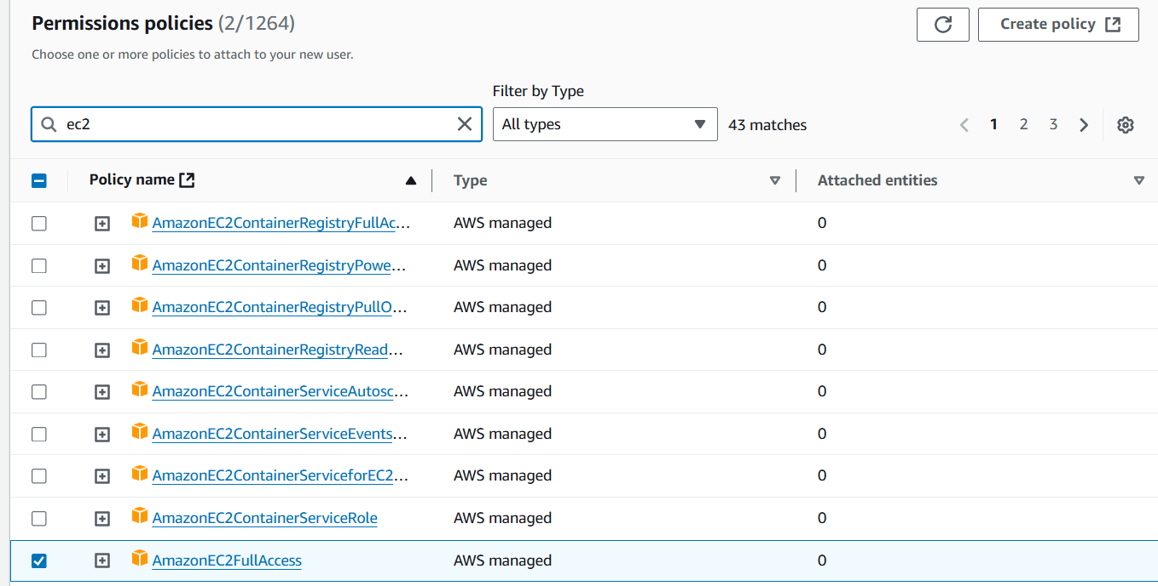

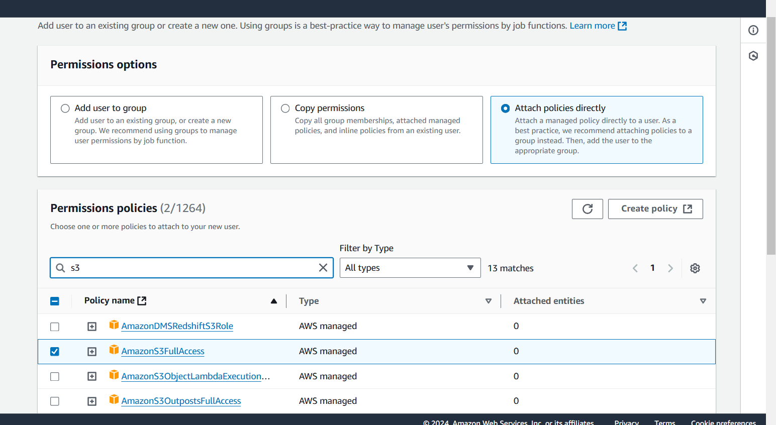

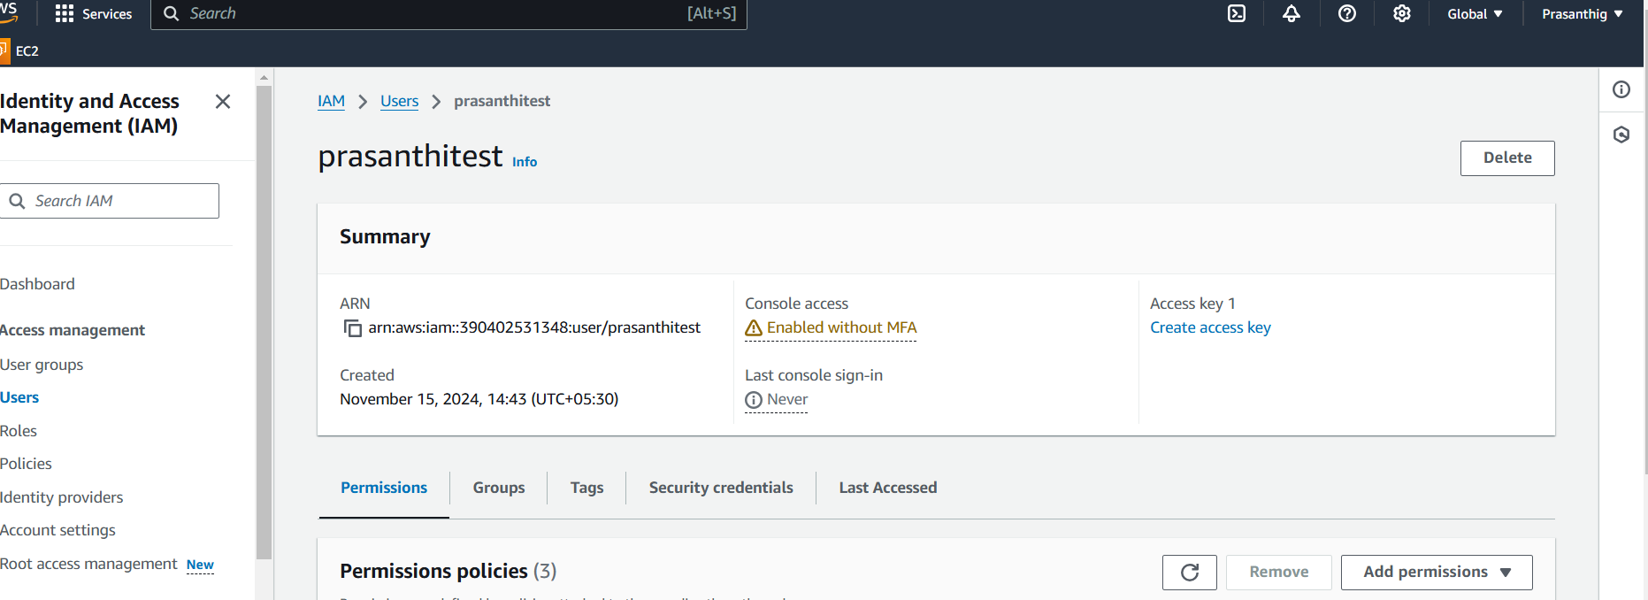

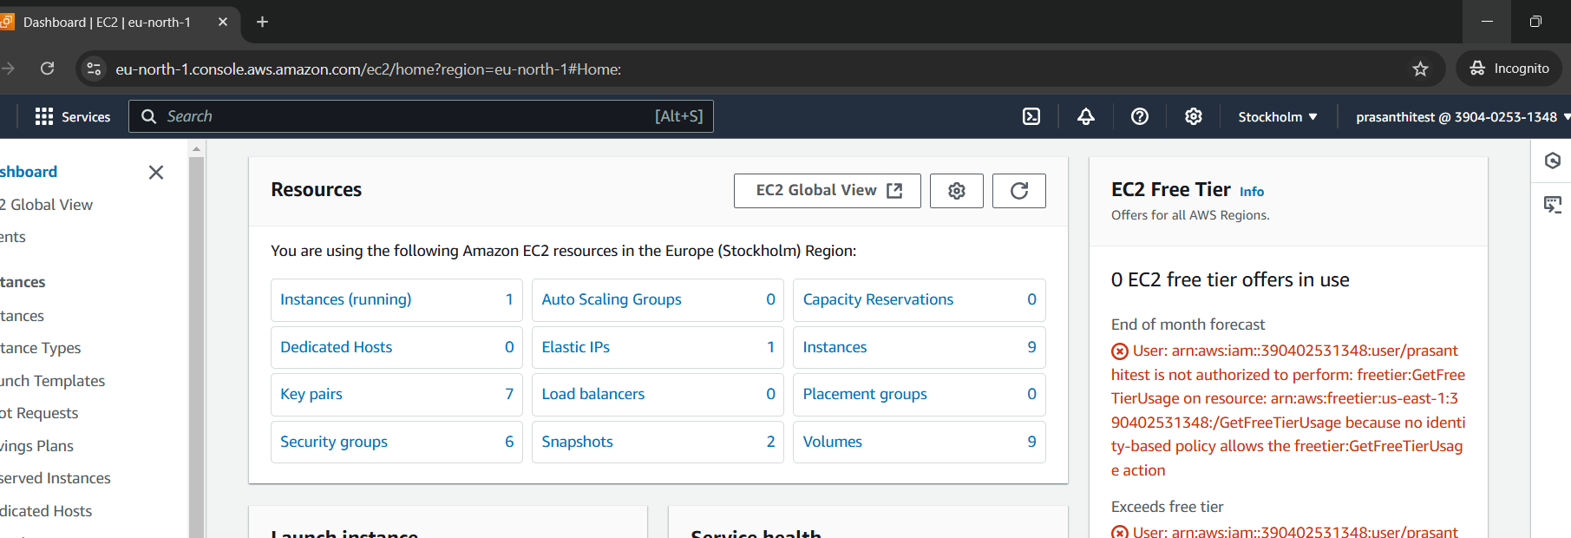

2) Create one Group in IAM and Assign Read access for ec2.

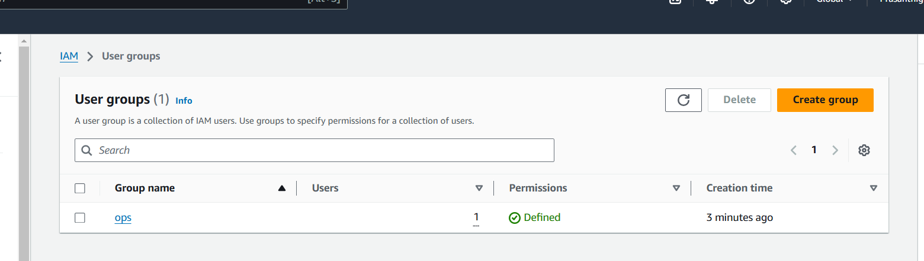

3) Create a new user with name Devops and add to the group created in task2.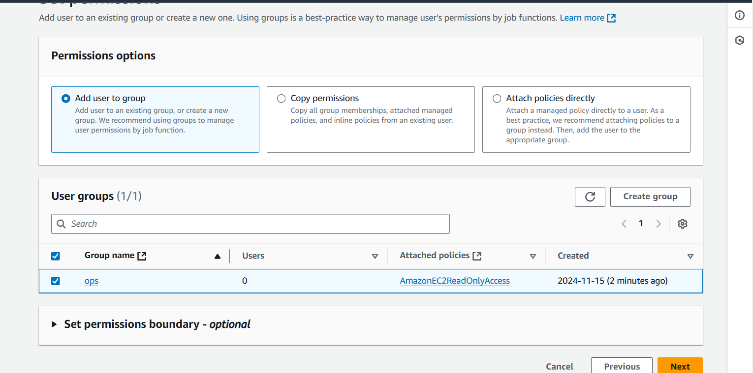

4) Write a bash script to create a IAM user with VPC full access.

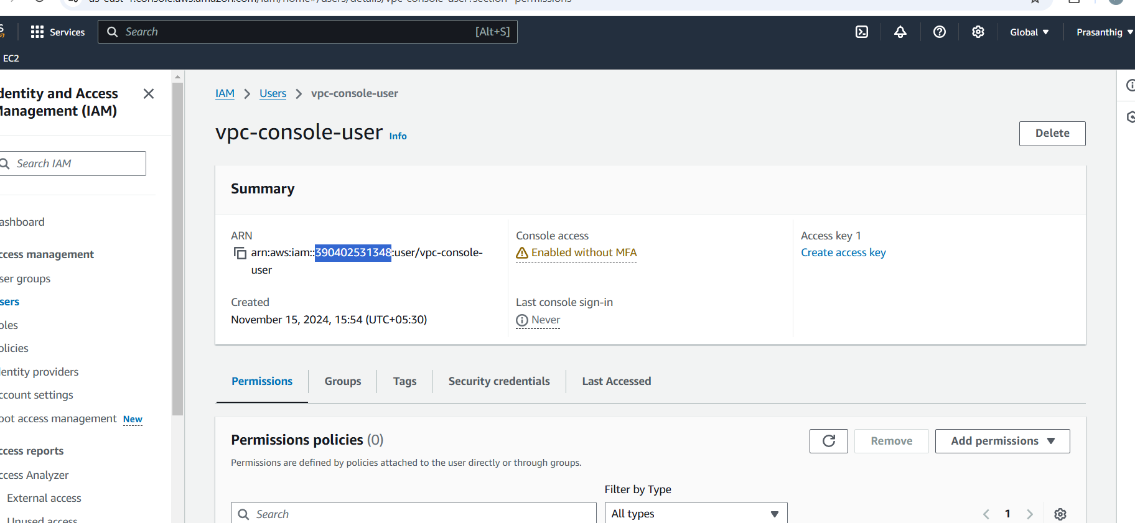

#!/bin/bash

USER_NAME="devops"

PASSWORD="Mypassword@123"

# Create the IAM user

aws iam create-user --user-name "$USER_NAME"

# Create a login profile to set the password

aws iam create-login-profile --user-name "$USER_NAME" --password "$PASSWORD" --password-reset-required

echo "IAM user '$USER_NAME' created with console access."

